Sound Processing

Task 2 Report

Subtractive synthesis of sound

G2

*Maciej Badura 194401*

*Panajoti Rriska 201622*

1. Introduction

The aim of our task was to implement sound synthesis methods enabling to generate sound in real-time. These methods should be used in a self-constructed application for creating sound and sound effects.

2. Sound timbre creation

The task comprises methods of subtractive sound synthesis based on the scheme below

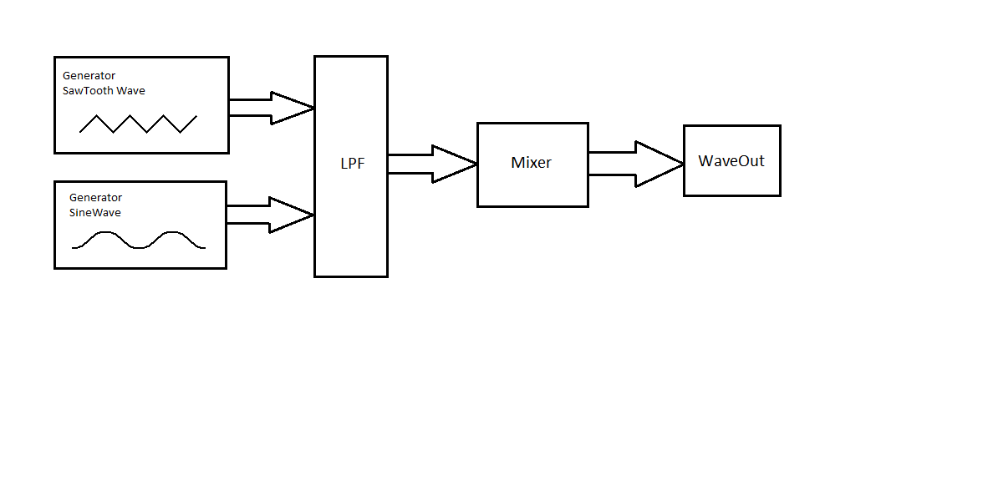

After creating our Signals our goal was to experiment and formulate interesting sounds. To achieve this used a Mixer. The mixer combines different sounds and when user presses buttons simultaneously it generates the mixtures of different sounds created. Before we pass our samples to the mixer we use a LowPassFilterProvider class which returns our filtered samples. As a cut-off frequency we set 4kHz and resonance parameter Q to 0.7f for best results.

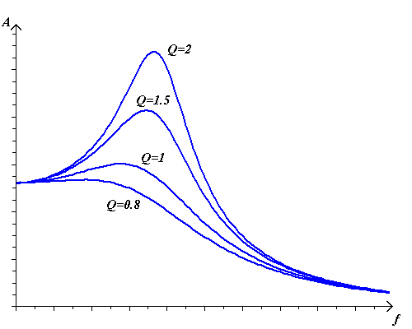

We created a sound timber with several input buttons with different frequencies and durations specified from the table below

|  |  |  |  |  |  |  |  |  |  |
| --- | --- | --- | --- | --- | --- | --- | --- | --- | --- |
| Frequency [Hz] | 391.9 | 329.6 | 329.6 | 349.6 | 293.7 | 293.7 | 261.6 | 329.6 | 391.9 |
| Duration  [ms] | 400 | 400 | 400 | 400 | 400 | 400 | 200 | 200 | 400 |

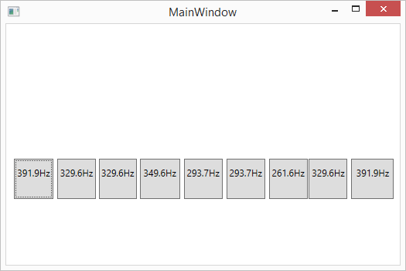

3. Ocean sound generation

Second part of this task was about generating ocean sound. To do this we had to firstly generate white noise and then filter it with a low pass filter with oscillating cut-off frequency. The scheme of ocean sound generator is presented below.

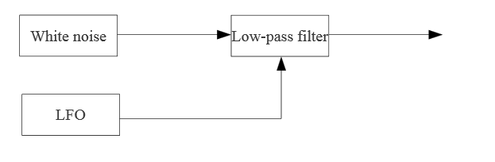

To obtain white noise we generated random samples with values between -1 and 1 with sample rate equals to 44100Hz.

For the low pass filter we used following formula:

yn = a0xn + a1xn-1 + a2xn-2- b1yn-1 - b2yn-2

where x and y represent current and previous samples of the input and output signals, respectively and a0, a1, a2, b1, b2 are the parameters of the filter. For a given sampling frequency fs and the desired cutoff frequency f and resonance Q the values of the parameters of the low-pass filter are computed as:

s = sin(2πf / fs)

c = cos(2πf / fs)

α = s / (2Q)

r = 1 / (1 + α)

a0 = 0.5(1 – c)r

a1 = (1 – c)r

a2 = a0

b1 = -2cr

b2 = (1 – α)r

The following parameter were set to obtain the best result:

Q = 0.8

LFO amplitude = 800Hz

LFO minimum value = 300Hz